1. The probability that 40 or more people will arrive in an hour is 27.63%.

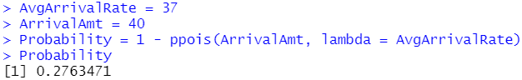

1. The probability that a customer can be served in less than 1 minute is 55.06%.

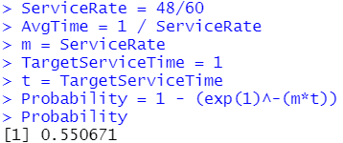

1. For a service rate of 103 repairs per hour, we can see that the average utilization is at 92%, meaning the workers are doing something 92.23% of the time, meaning 7.77% of the time spent at work is downtime for the workers. We can also see that the average queue length is 10.95, the average queue wait time is 6.91 minutes, the average number of people in the system are 11.87, and the average total time spent in the system is 6.92 minutes.

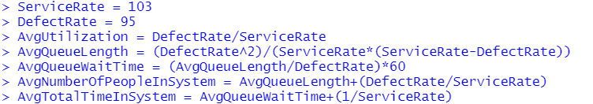

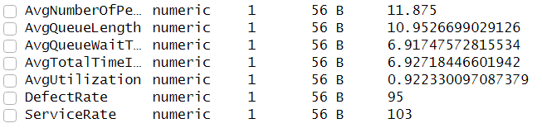

When we expand the range of the service rate from just analyzing 103 repairs per hour to a range of 95 to 120 service rate per hour, we can see the effects of the change in service rate on each of the averages. The graphs have a similar shape besides utilization, which just shows that when the defect rate and service rate are the same, the workers are occupied almost 100% of the time and have no down time. Higher service rate decreases the averages for the other values but the effects largely fall off after a service rate of 110 per hour.



